INTRODUCTION OF TRANSMISSIONS BELTS
T type industrial rubber timing belt
- T type industrial rubber timing belt
- Automotive timing belt
- Arc tooth industrial rubber timing belt
- Double sided timing belt

① T type industrial rubber timming belt
practicality: | 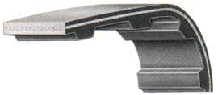
design: | 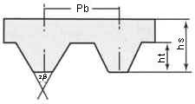
parameter
  Type | Pitch  Pb (mm) | Tooth height ht (mm) | Belt thickness  hs (mm) | Angle  2β°
  MXL | 2.032 | 0.51 | 1.14 | 40
  XL | 5.080 | 1.27 | 2.30 | 40
  L | 9.525 | 1.91 | 3.60 | 40
  H | 12.70 | 2.29 | 4.30 | 40
  XH | 22.225 | 6.35 | 11.20 | 40
  XXH | 31.750 | 9.53 | 15.70 | 40
  T5 | 5 | 1.20 | 2.20 | 40
  T10 | 10 | 2.50 | 4.50 | 40
  T20 | 20 | 5.00 | 8.00 | 40

②Automotive timing belt
practicality | 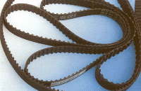
design: | 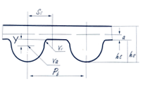MY、MR、ZD、YF型
design: | 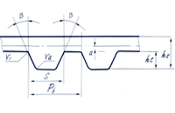ZA、ZB型
design: | 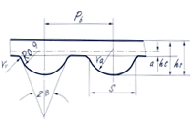ZBS型
parameter
  TYPE | PITCH | BELT HEIGHT | TOOTH  HEIGHT | a | Rr | Ra | S | WEDGE | Ss | Y
  ZA | 9.525 | 4.1 | 1.91 | 0.686 | 0.51 | 0.51 | 4.65 | 40
  ZB | 9.525 | 4.5 | 2.29 | 0.686 | 1.02 | 1.02 | 6.12 | 40
  MY | 8.00 | 5.21 | 3.06 |  | 0.63 | 2.20
  MR | 9.525 | 5.69 | 3.54 |  | 0.76 | 2.52
  ZD | 9.525 | 5.5 | 3.50 | 0.686 | 0.76 | 2.45 |  |  | 3.27 | 1.05
  YF | 8.000 | 5.2 | 3.04 | 0.686 | 0.64 | 2.11 |  |  | 2.84 | 0.93
  ZBS | 9.525 | 5.1 | 2.8 | 0.686 | 1.02 | 3.6 | 6.12 | 40

③Arc tooth industrial rubber timing belt
practicality: | 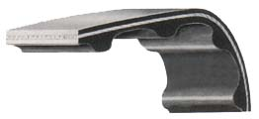
design: | 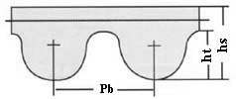HTD
design: | 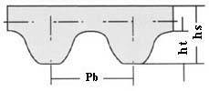STPD
design: | 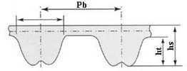RPD
parameter
  Gear code | Type | Pitch  Pb(mm) | Tooth height ht(mm) | Belt thicknes hs(mm)
  HTD | 3M | 3 | 1.17 | 2.4
  HTD | 5M | 5 | 2.06 | 3.8
  HTD | 8M | 8 | 3.36 | 6.00
  HTD | 14M | 14 | 6.02 | 10.00
  STPD/STS | S3M | 3 | 1.14 | 1.9
  STPD/STS | S4.5M | 4.5 | 1.71 | 2.81
  STPD/STS | S5M | 5 | 1.91 | 3.4
  STPD/STS | S8M | 8 | 3.05 | 5.3
  STPD/STS | 14M | 14 | 5.3 | 10.2
  RPP/HPPD | 5M | 5 | 1.95 | 3.5
  RPP/HPPD | 8M | 8 | 3.2 | 5.5
  RPP/HPPD | 14M | 14 | 6.00 | 10
  RHP | 8M | 8 | 3.2 | 5.0
  RHP | 14M | 14 | 6.00 | 10

④Double sided timing belt
practicality | 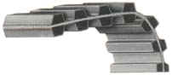
design:A | 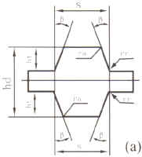
design:B | 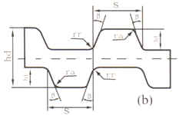
parameter | DOUBLE SIDED TIMING BELT HEIGHT  DOUBLE SIDED TIMING BELT SPECIFICATION
  Pitch Code | Nominal Height
  Pitch Code | mm | inch
  D-MXL | 1.53 | 0.06
  D-XL | 3.05 | 0.12
  D-L | 4.58 | 0.18
  D-H | 5.95 | 0.234
  D-XH | 15.49 | 0.61
  D-XXH | 22.11 | 0.87
  D-T2.5 | 2 | 0.08
  D-T5 | 3.40 | 0.134
  D-T10 | 7.0 | 0.275
  D-T20 | 13.0 | 0.512
  HTD.DA-8M | 8.17 | 0.32
  Type | Pitch Length (mm) | Teeth No.
  D540L | 1371.60 | 144
  D240H | 609.60 | 48
  D330H | 838.20 | 66
  D450H | 1143.00 | 90
  HTD-DA1000-8M | 1000 | 125
  HTD-DA1200-8M | 1200 | 150
RiBBED BELT
△Characteristics It the product：
It has advantages of borth V-belt and flat-belt,soft and tough,taut and efficient.
All kind of ribbed rubber belts produced in our factory,have thead vantages of wearabillity,resistance to high or low temperature and long length of life
practicality： | 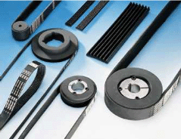
design： | 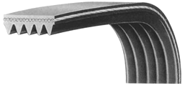
design | 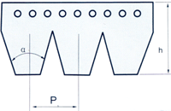
parameter
  Mode | joint-pitch |  | total heighth | gear heighth | gear root | gear top | wedge
  Mode | norminal joint pitch | actual joint pitch | H | h | R1 | R2 | a°
  PH | 1.60 | 1.60 | 3.00 | 1.33 | 0.15 | 0.30 | 40
  PJ | 2.40 | 2.34 | 4.00 | 2.35 | 0.20 | 0.40 | 40
  PK | 3.60 | 3.56 | 7.00 | 3.20 | 0.30 | 0.60 | 40
  PL | 4.8 | 4.70 | 10.00 | 4.89 | 0.40 | 0.40 | 40
  PM | 9.60 | 9.40 | 17.00 | 10.35 | 0.75 | 0.75 | 40

V – Belt(Wrapped V belt, Narrow V belt, Banded V belt)

Practicality: | 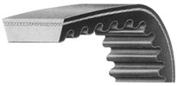
design： | 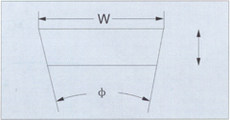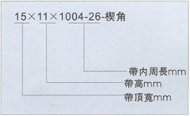
parameter
  Specification | Inner perimeter | Specification | Inner perimeter | Specification | Inner perimeter
  25*11*520-28 | 520 | 25*10*825-24 | 825 | 28*8*1060-25 | 1060
  23*7*503-36 | 530 | 28*10*830-34 | 835 | 40*14*1068-24 | 1068
  31*12*568-37 | 568 | 28*9*860-34 | 860 | 32*12*1075-25 | 1075
  26*12*600-30 | 600 | 38*12*863-6 | 863 | 55*12*1090-23 | 1090
  22.4*6*620-20 | 620 | 30*10*878-24 | 878 | 28*10*1120-12 | 1120
  20*6.5*630-30 | 630 | 22*16*880-32 | 880 | 30*9*1120-26 | 1120
  6.5*648-24 | 648 | 34*10*912-35 | 912 | 32*13*1145-28 | 1145
  25*8*655-26 | 655 | 32*12*914-11 | 914 | 52*16*1180-28 | 1180
  28*9*665-34 | 665 | 41*12*930-24 | 930 | 38*12*1275-30 | 1275
  25*8*700-44 | 700 | 36*10*958-30 | 958 | 27*11*1320-6 | 1320
  36*12*725-30 | 725 | 50*12*960-36 | 960 | 36*13*1400-30 | 1400
  27*11*728-30 | 728 | 19*8*980-24 | 980 | 50*17*1440-30 | 1440
  22*8*740-20 | 740 | 19*8*1000-24 | 1000 | 70*19*1445-30 | 1445
  27*9*760-30 | 760 | 45*11*1004-26 | 1004 | 50*13*1453-24 | 1453
  32*10*790-30 | 790 | 35*14*1007-20 | 1007 | 46*12*1539-23 | 1539
  28*11*810-21 | 810 | 28*15*1035-30 | 1035

AUTOMOBILE  V-BELT | EMBED Word.Picture.8
MOTORCYCLE  V-BELT | 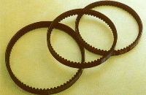
parameter  (AUTO)
  TYPE | TOP WIDTH | HEIGHT
  TYPE | TOP WIDTH | Ordinary cutting-side type | Rubber lined with cloth cutting-side type | Toothed cutting-side type
  AV10 | 10.0 | 7.5 | 7.5 | 8.0
  AV13 | 13.0 | 8.5 | 8.5 | 9.0
  AV15 | 15.0 | - | - | 9.0
  AV17 | 17.0 | 9.5 | 9.5 | 11.0
  AV22 | 22.0 | - | - | 13.0
parameter  (MOTORCYCLE)
  Model | MV15.5 | MV16.5 | MV17 | MV18 | MV19 | MV20 | MV22
  TOP height | 15.5 | 16.5 | 17 | 18 | 19 | 20 | 22
  Belt height | 8.5 | 8.5 | 8.5 | 9 | 10 | 10 | 11

AUTO V-BELT
practicality
practicality | 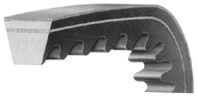
Specification | 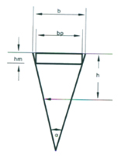
parameter
  项目\截型 | 基准制（公制） |  |  |  | 有效制（类别）
  项目\截型 | SPZ | SPA | SPB | SPC | 9N(3V) | 15N(5V) | 25N(8V)
  顶高 mm | 10.0 | 13.0 | 17.0 | 22.0 | 9.0 | 15 | 25.0
  节宽(dp) | 8.5 | 11.0 | 14.0 | 19.0
  带高 mm | 8.0 | 10.0 | 13.0 | 18.0 | 8.0 | 13.0 | 23.0
  顶到节面距离 mm | 2.0 | 2.8 | 3.5 | 4.8
  楔角(a)度 | 40 | 40 | 40 | 40 | 40 | 40 | 40
  全截面拉伸强度KN/根 | 2.45 | 2.95 | 5.39 | 9.875 | 2.45 | 5.39 | 12.75
  定负荷伸长率 %<= | 8 | 8 | 8 | 8 | 8 | 8 | 8

Rubber Flat Belt
Employing reinforcement with high intensity, slight eIongation and anti-wearing out as strong base, high-speed rubber flat belt is characteristic as strong transmission power and anti-wearing out.EmpIoying imported chloroprene rubber, with anti-heat, anti-oil, anti-wearing out and long life. Thus it becomes most satisfactory high-speed transmission fIat belt

practicality： | 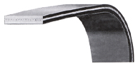
parameter
  Inner perimeter(Li mm)
  316 | 323 | 330 | 335 | 341 | 354 | 361 | 363
  364 | 370 | 379 | 385 | 394 | 396 | 404 | 413
  415 | 420 | 432 | 446 | 450 | 462 | 472 | 481
  502 | 508 | 525 | 545 | 556 | 566 | 571 | 575
  590 | 597 | 604 | 608 | 610 | 620 | 624 | 625
  630 | 634 | 642 | 644 | 650 | 664 | 676 | 678
  680 | 684 | 685 | 687 | 705 | 707 | 723 | 756
  760 | 774 | 781 | 794 | 800 | 805 | 813 | 814
  830 | 836 | 851 | 853 | 867 | 880 | 889 | 890
  892 | 897 | 911 | 946 | 955 | 965 | 969 | 980
  1000 | 1018 | 1022 | 1043 | 1047 | 1052 | 1075 | 1085
  1090 | 1095 | 1107 | 1116 | 1120 | 1131 | 1159 | 1174
  1181 | 1200 | 1220 | 1247 | 1260 | 1281 | 1285 | 1294
  1319 | 1335 | 1385 | 1555 | 1586 | 1564 | 1604 | 1649
  1665 | 1690 | 1703 | 1728 | 1778 | 1816 | 1835 | 1868
  1893 | 1945 | 2001 | 2020 | 2048 | 2070 | 2078 | 2100
  2115 | 2120 | 2145 | 2199 | 2319 | 2327 | 2343 | 2380
  2409 | 2469 | 2579 | 2609 | 2669 | 2670 | 2759 | 2838
  2840 | 2849 | 2850 | 2883 | 2930 | 2944 | 2964 | 3034
  3090 | 3154 | 3204 | 3420 | 3480 | 312

Pulley
- Belt and pulley of our company can be attachment or replacement of imported belt and pulley.
2. Please supply drawing when you order.We can also draw for clients as their supplied specification, hole, key way and width.
3. The tolerance of outside diameter,end bounce & wrap direction of pulley should conform to Tab1, Tab2 & Tab3.
4. Width of different specification of timing belt and pulley must conform to Tab4.
5. Outside diameter of pulleys and size should be as Tabs' regulation.
6. We can also produce pulleys even sizes are not in the form.
7. The material of pulley mainly composed of carbon steel,if possible,aluminum alloy nylon can also be employed;if external diameter is larger than 250mm,iron is used.

practicality： | 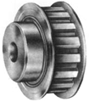
practicality： | 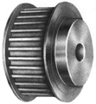
practicality： | 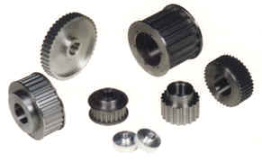

design: | 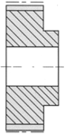AS Type
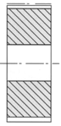BStype
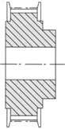AFtype
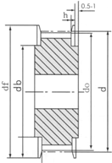BFtype
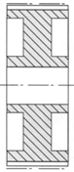W type

parameter: | 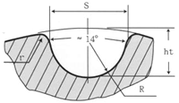HTD
parameter
  Type | Belt width |  | Min.width of pulley
  Type | Code | Belt width | Double capped edge pulley | Single capped edge pulley | No capped edge pulley
  MXL | 012 | 3.0 | 4 | 5 | 6
  MXL | 019 | 4.8 | 5.8 | 6.8 | 7.8
  MXL | 025 | 6.4 | 7.5 | 8.5 | 9.5
  XL | 025 | 6.4 | 7.5 | 8.5 | 9.5
  XL | 031 | 7.9 | 9 | 10 | 11
  XL | 037 | 9.5 | 11 | 12 | 13
  L | 050 | 12.7 | 14 | 15.5 | 17
  L | 075 | 19.1 | 21 | 22 | 24
  L | 100 | 25.4 | 27 | 28.5 | 30
  H | 075 | 19.1 | 21 | 23 | 25
  H | 100 | 25.4 | 27 | 29 | 31
  H | 150 | 38.1 | 40 | 42 | 44
  H | 200 | 50.8 | 53 | 55 | 58
  XH | 200 | 50.8 | 57 | 60 | 63
  XH | 300 | 76.2 | 84 | 87 | 90
  XH | 400 | 101.6 | 111 | 114 | 117
  XXH | 200 | 50.8 | 57 | 61 | 64
  XXH | 300 | 76.2 | 84 | 88 | 92
  XXH | 400 | 101.6 | 111 | 115 | 118
  XXH | 500 | 127.0 | 138 | 142 | 145
  T2.5 | 4 | 4 | 6 | 7 | 8
  T2.5 | 6 | 6 | 8 | 9 | 10
  T2.5 | 10 | 10 | 12 | 13 | 14
  T5 AT5 | 6 | 6 | 8 | 9 | 11
  T5 AT5 | 10 | 10 | 12 | 13 | 15
  T5 AT5 | 16 | 16 | 18 | 20 | 22
  T5 AT5 | 25 | 25 | 27 | 29 | 31
  T10  AT10 | 16 | 16 | 18 | 22 | 24
  T10  AT10 | 25 | 25 | 27 | 30 | 33
  T10  AT10 | 32 | 32 | 34 | 37 | 40
  T10  AT10 | 50 | 50 | 53 | 56 | 59
  T20  AT20 | 32 | 32 | 35 | 38 | 40
  T20  AT20 | 50 | 50 | 53 | 56 | 60
  T20  AT20 | 75 | 75 | 78 | 81 | 85
  T20  AT20 | 100 | 100 | 105 | 108 | 112
  3M S3M | 6 | 6 | 9 | 10 | 11
  3M S3M | 9 | 9 | 12 | 13 | 14
  3M S3M | 15 | 15 | 18 | 19 | 20
  5M  S4.5M S5M | 9 | 9 | 12 | 13 | 14
  5M  S4.5M S5M | 15 | 15 | 18 | 19 | 20
  5M  S4.5M S5M | 25 | 25 | 28 | 29 | 30
  5M  S4.5M S5M | 30 | 30 | 34 | 36 | 38
  8M S8M | 30 | 30 | 34 | 36 | 38
  8M S8M | 40 | 40 | 44 | 46 | 48
  8M S8M | 50 | 50 | 54 | 56 | 58
  8M S8M | 85 | 85 | 90 | 92 | 94
  14M  S14M | 55 | 55 | 65 | 68 | 70
  14M  S14M | 85 | 85 | 95 | 99 | 102
  14M  S14M | 115 | 115 | 126 | 130 | 133
  14M  S14M | 170 | 170 | 180 | 183 | 187
  20M | 70 | 70 | 80 | 84 | 89
  20M | 85 | 85 | 96 | 100 | 104
  20M | 115 | 115 | 127 | 131 | 134
  20M | 170 | 170 | 182 | 185 | 190
  20M | 230 | 230 | 245 | 248 | 254
  20M | 290 | 290 | 295 | 300 | 310
  20M | 340 | 340 | 355 | 360 | 370

