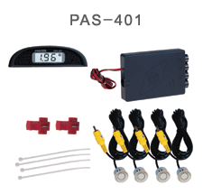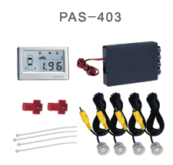

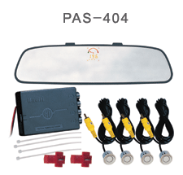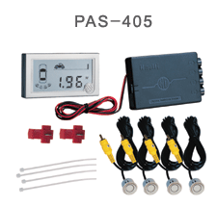

COLORS AVAILABLE:
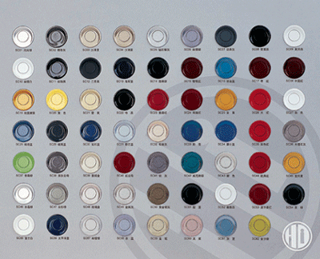

Contents
Products

Introduction -------------------------------------------------------------------
System Composition --------------------------------------------------------

Features -----------------------------------------------------------------------

Technical Parameters--------------------------------------------------------
Usage
Power on ----------------------------------------------------------------------
Display ------------------------------------------------------------------------
Alarm Volume Adjustment-------------------------------------------------
Attentions ---------------------------------------------------------------------
Sensing Range and Warning Methods ------------------------------------

Notes ----------------------------- ---------------------------------------------
Maintenance ------------------------------------------------------------------

Service items
Warranty --------------------------------------------------------------------
Service Condition ----------------------------------------------------------
Notes (Declaration or Statements)
- This system is designed to be an aid and cannot replace the need to drive carefully.
- Under no circumstances will the manufacturer or supplier accept any responsibility or can be held liable for any direct or indirect, incidental or consequential damage, or for injuries resulting from installing or use of this system.
- HD is not in charge of any extra promise getting from the dealers.
- Whilst every precaution has been taken in this publication, HD does not warrant the accuracy or completeness of the information in this publication and HD reserves the right to alter specifications without notice.
- To the extent permitted by law, HD excludes all liability, including negligence for any loss incurred in reliance on the contents in this publication.

Cautions
- Please read this manual carefully before using the product.
- Please practice reverse parking using different obstacles to grasp this product’s performance.
- Though the minimum detecting distance is 0.35m, it is still recommended to keep enough space to stop your car. Considering the cars’ inertia, it would be better to stop your car when the distance on the display is shorter than 0.60m.
- The reverse speed should be less than 5 km/h (3.1 mph).

Products

·Introduction
HD is an alert system for reverse. It comprises up to 4 sensors, a central control processor and a display unit It is based on the principle of ultrasonic and technology of data’s fuzzy processing. The system detects and displays the distance of the obstacle automatically in reverse and signals the position of the obstacle with distance display, sound warning, zone caution, and direction of the orientation.
·Composition

Fig 1
·Features
1. Accurate measurement and stable readout.
2. High sensitivity, wide detection range and small blind zone.
3. Full function, include digitalized distance display/sound warning /zone caution / orientation indication /build-in test.
4. The system is merged into the car perfectly.
5. Apply to most cars and ease of installation.

·Technical Parameters

1. Operating voltage range: DC 10V ~ 16V

2. Maximum power consumption: 4W

3. Working ambient temperature: -35°C ~ +70°C

4. Detecting distance: 0.35 m ~ 2.50m

5. Measuring error: ±0.02m

6. Sensor detection angle: 120°

Usage

Power on
The system is automatically activated when engaged reverse gear. Self-check diagnostic program will be first done after the system is powered on, then the buzzer will give out a number of beeps in correspondence with the number of available sensors. Meanwhile the correspondent direction indicators will be on as well. After the above stage, the system is ready now.

Display
-----display the distance between sensor and a closest obstacle.
-----Indicate zone stage with a different rhythem.
-----Denote the closest obstacle direction with flashing LED (PAS401&PAS404) or direction icon (PAS405).
-----Indicate zone stage with a pointer (PAS404) or icon (PAS401&PAS405).

Warning Volume Adjustment
There are two volume levels (H) & (L). The switch is on the back cover of display units.

Attention
Reverse speed should be less than 5 km/h (3.1 mph)

Be in dangerous zone (0.60m)

Slender obstacles can be detected at short distance only

Sensing Range and Warning Method

Notes
HD Parking Assistance System adopts wide angle, high sensitivity sensors and technology of fuzzy data processing. Blind zone is small relatively. But in some cases, the readout on the display may be not as same as the reality due to the sensor installed level, obstacle shape\location\angle and reflection character and so on. Please check the condition behind your car before reversing. Some examples are given below.

- As shown in Fig. a, point B is lower than sensors, and point A has a strong reflection, the distance of CA will be shown first. When the obstacle is within
the blind zone, neither A nor B will be detected.
This usually occurs when the obstacle (such as curbstone, short pole) is lower than
the level of sensors.

- As shown in Fig. b, in the case that although the obstacle A is pretty low, it has strong reflection, during reversing, the distance between sensor and obstacle A is shown first. After obstacle A is within blind zone, the distance between sensor and obstacle B will be shown.

- As shown in Fig. c, though point A is closer to the car than point B, the distance from sensor to point B is shown.

- As shown in Fig. d, in case of small angle (α) of incidence to the obstacle, such as glass wall or other smooth plane, the obstacle is not detected.

- As shown in Fig. e, point B will be detected sooner or later, but point A may not be detected forever.

- As show in Fig. f, the reading may moves up and down between 1.2m and 2.2m because the small obstacle A is at the critical detecting point. The reading will be stable after a little closer to the obstacle A.

- As shown in Fig. g, on certain conditions, for example, ground might be detected and the distance from sensor to ground will be displayed.

- As shown in Fig. h, not all obstacles can be detected from 2.5m. For instance, a person is detected from 1.3m because of the weak reflection of clothes.
- As shown in Fig. i, the distance is shown form sensor A to B, rather than C to D.

- Maintenance
- Clean up the sand, ice, snow or any other dirt on sensors’ surface timely and make the gap on the sensor’s centre surface clear.

- Re-paint is allowed on sensors’ surface with slight coat. Be attention, thick paint will affect detection.

- Troubleshooting
Problem | Cause | Remedy
No display  When reversing | a. Power is not on  b. Display unit is not  connected well to controller | a. Check power connection  b. Check the connection from  display unit to controller
Wrong orientation indication | Wrong sensors’ order | Change the order of sensors
Constantly display “—p—“ | An object within 0.35m is detected constantly | Adjust the sensors’ position or angle
Display a fixed distance | a. Ground is detected  b. Sensors’ direction is wrong | Adjust the sensors’ position or direction
Orientation indicator not on | a. The connector is not well plugged in  b. The connector is plugged in while power is on | a. Check if the connector is firmly connected  b. Switch on power again
Works properly as light is off while improperly as light is on | The connection of ground wire is wrong | Connect ground wire to the right place

Service items
- Warranty
HD warrants the Parking Assistance System devices shall be free of any faulty parts or workmanship for a period of 3 years from the date of purchase.
- Service Condition
The warranty is subject to the following conditions:
- Warranty invalidated for any reason other than faulty manufacture or parts.
- Broken seal voids warranty.
- The serial number should be same as that registered.
- No warranty claim will be validated unless the customer can establish purchase of the Parking Assistance System device from HD or its authorized retailers.

